**PBPC action plan**

Trying to separate the PBPC requirement region to region as APAC, EMEA and North America because the requirement appeared to be little different. In India the requirement was very clear. They wanted PBPC at turbine level, the reclass to happen at turbine level, for others they wanted it at project level because the process in NM is such that pbpc is automated and PBUBR(Un Billed Revenue) is also automated. It is automatic program but we handle it in different way only in monthly basis everytime the support team runs the program for Americas and they do the reclass.( Is reclass the conversion from progress billing to progress collection?).

Initially they thought to club emea and India because initially emea also wanted it to be in turbine level. Call with Fredrick who is emea controller. In pbpc he wants completely auto. In RACES when cash application is happening at AR SLA, PBPC is getting kicked off for all countries in scope of blueprint, but Germany and Spain, that process is manual, so suggestion of automating the part where on AR cash application the pbpc reclass will be invoked as in, in that event it will be considered for reclass.

We will go with India first and present to board. America doesn’t have multi currency report, for other countries there is pbpc multi currency report but in case of America it isn’t there mainly because there is only US dollar. But in scenario when contract is signed in multi currency then it will not be helpful for them.

Plan to do as part of Q2 release. How much testing is needed>🡪Lot of testing needed.

Effort estimate needed from TCS.

Auto reclass in pbpc is turbine level, emea is still doubtful, but if we get confirmation we can club India and emea. Decide on turbine level or project.

Which is more difficult?

Turbine, as here need to track turbine to turbine, 240 turbine when you go one by one, in project level you can have one project with multiple turbine, so complexity at turbine level. Whether emea in Q2 depends on effort estimate.(What is effort estimate)

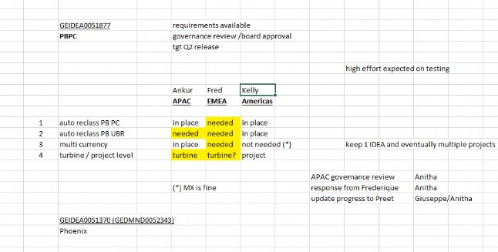

[CLICK](sharepoint%20first%20website.docx)